🏆 Bend South Little League

All Stars Travel Guide

🗺 Tournament Location
Kramer Field – The Dalles, OR
- Baseball Fields: 808 Walnut St
- Softball Fields: 807 Webber St
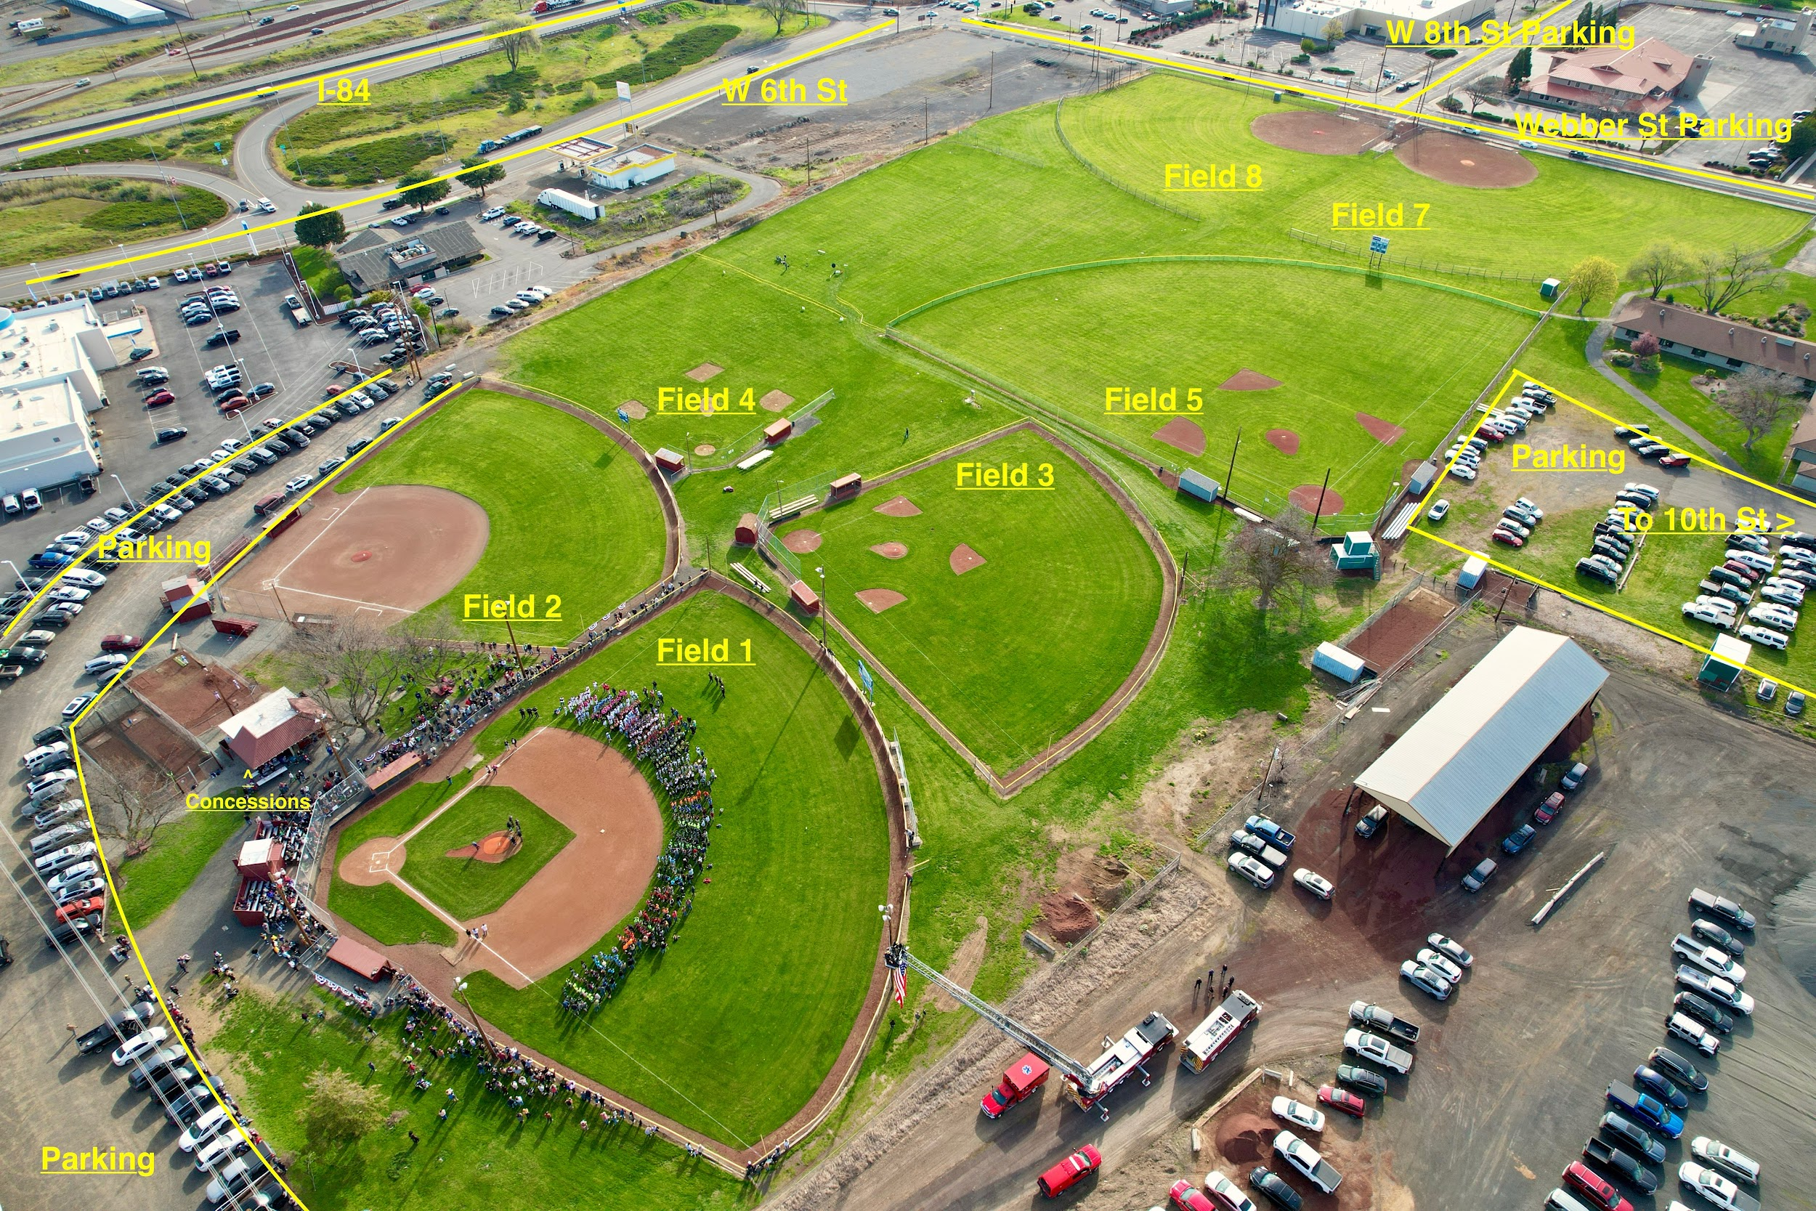 | 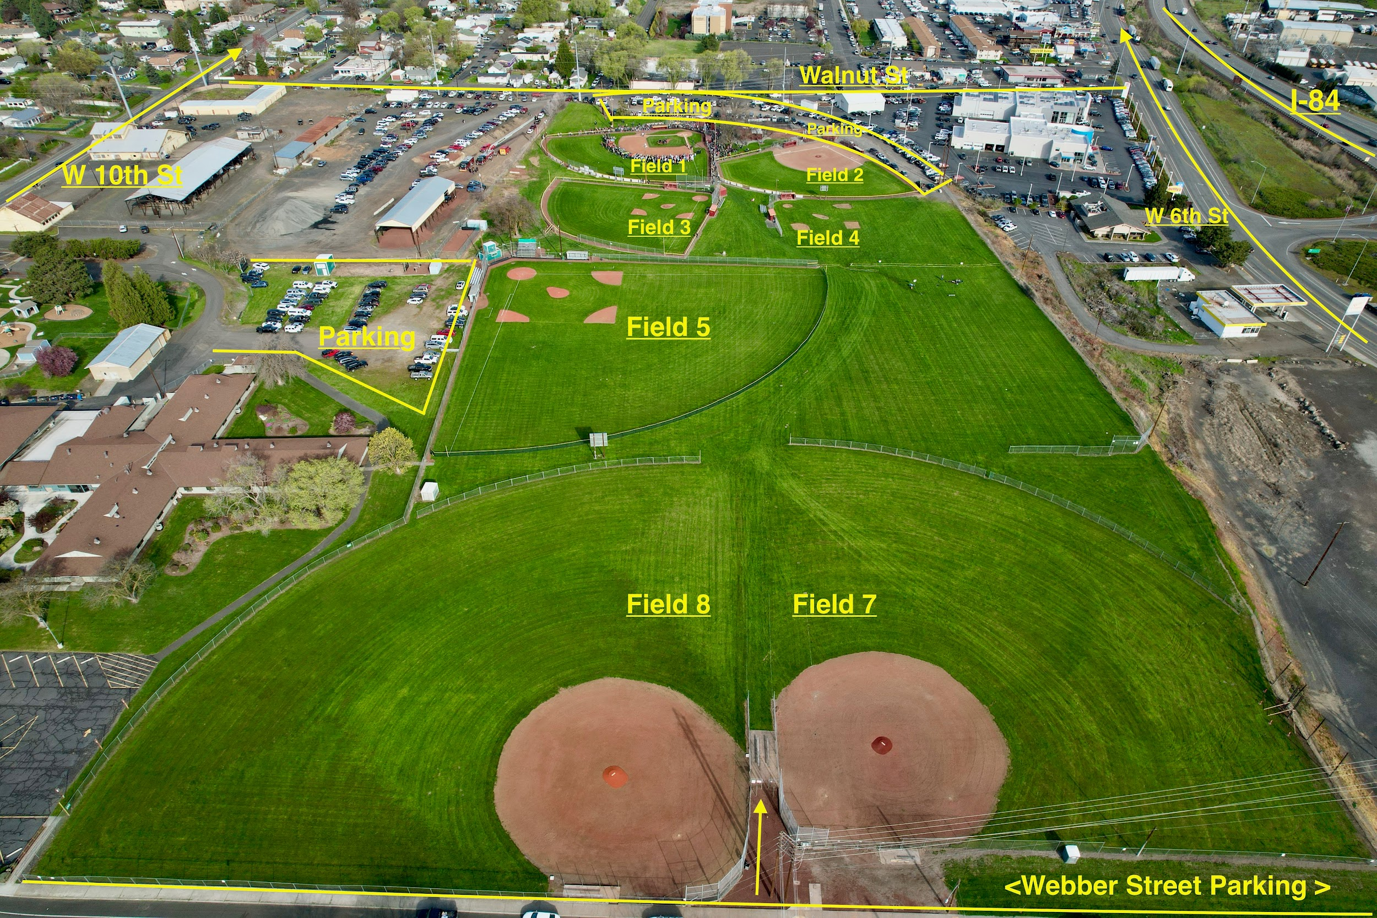

Note: The complex has two entrances. Be sure you’re arriving on the correct side based on the team’s game location.

🏨 Lodging Info

🛏 Hotel Room Block (Limited Availability!)
Comfort Inn & Suites – The Dalles
- 🔗 Booking Link
- 📞 Call & reference: Bend South Little League Block
- Rooms Available: 10 Double Queens, 5 Kings, 2 Kings w/ Pull-Out Sofas
- Rate: $175/night
- ⏳ Deadline: Book by Noon 5/20

🏨 Other Lodging Suggestions
(Provided by The Dalles Little League + Additional Options)
All hotels are within or near town. Book early!
Hotel Name | Notes & Booking Info
Cousins Country Inn | 🛏 Charming, family-run; on-site restaurant; walkable to fields🔗 Book Cousins Inn
Fairfield Inn & Suites | 🛏 Modern Marriott hotel, free breakfast, 1 block from fields🔗 Book Fairfield Inn
Columbia River Hotel | 🛏 Best Western Plus; near the dam, McDonald’s, & Starbucks🔗 Book Columbia River Hotel
Holiday Inn Express | 🛏 Central location; indoor pool; hot breakfast🔗 Book Holiday Inn
The Dalles Inn | 🛏 Downtown vibe, walking distance to shops and dining🔗 Book The Dalles Inn
Comfort Inn Columbia Gorge | 🛏 Near Starbucks, pet-friendly, wine country feel🔗 Book Comfort Inn CG
Motel 6 – The Dalles | 💸 Budget-friendly; pet-friendly with no extra fee; basic amenities🔗 Book Motel 6
Super 8 – The Dalles | 💸 Budget option; close to restaurants and I-84🔗 Book Super 8
Celilo Inn | 🌄 Scenic boutique hotel overlooking Columbia River Gorge; seasonal pool🔗 Book Celilo Inn

🧾 Helpful Reminders:
- Ask about cancellation policies — some hotels may waive final nights if the team is eliminated early.
- Book early — local tournaments and summer tourism fill rooms fast!
- If your family needs pet-friendly accommodations, Motel 6 and Comfort Inn Columbia Gorge are solid bets.

🚐 RV Site Options
Site Name | Location | Rate | Contact
The Dalles Eagles RV Lot | 2006 W 7th St (across from Kramer Field) | $30/night (electric), $20/night (non-electric) | Samantha – 541-296-3172
Dufur City Park | ~10 mins east |  | Ask for Maria – 541-467-2356
W.E. Hunt Park (Tygh Valley Fairgrounds) | Wasco County |  | Nikki Lucas – 541-993-4123
Deschutes Recreation Park | ~15 mins east | 🔗 State Park Info
Memaloose State Park | 🔗 Reserve Here
Columbia Hills Historical State Park (WA) | 🧭 Requires Washington Discover Pass |  | 📞 509-773-3145  📧columbia.hills@parks.wa.gov
Fees:
Day Pass: $10 | Annual: $30
Trailer Dump: $5 | Watercraft Launch: $7

🚗Travel Conditions from Bend to The Dalles
Estimated Drive Time: ~2 hours 15 minutes
Distance: ~130 miles

🛣 Suggested Route:
US-97 N to I-84 W
- Take US-97 N through Madras and Shaniko
- Merge onto I-84 W at Biggs Junction
- Exit toward The Dalles (Exit 85 or 82 depending on your hotel/field)
⚠️ Travel Tips:
- Check traffic before departure: Use TripCheck.com for real-time ODOT updates.
- Watch for summer road work on Hwy 97 and I-84—flaggers and reduced speeds are common.
- Plan gas & snack stops in Madras, Maupin, or Biggs if caravanning.
- Wildfire season can cause smoky conditions or detours—have a backup plan just in case.

Tips for the Road:
- Download offline maps via Google Maps in case you lose signal around Shaniko.
- Pack a cooler with water, sports drinks, and fruit—hydration is half the battle!
- Carpool if possible to reduce parking hassle and help our planet. 🌍✨

☀️Weather Forecast: June 20–27, 2025 – The Dalles, OR
Expect warm and dry conditions—perfect for baseball, but do plan for sun exposure and hydration.

🌡️Temperature Overview
- Highs: Typically range from 76°F to 83°F, occasionally reaching up to 95°F
- Lows: Generally between 52°F and 58°F

🌤️Sunshine & Wind
- Sunshine: Approximately 12.6 hours of clear or partly cloudy skies per day
- Wind: Average speed of 11.1 mph, with June being the windiest month

🌧️Precipitation
- Rainfall: Light, averaging 0.4 inches over 3 days in June

Tips for Staying Cool
- Hydration: Ensure players and families have ample water.
- Cooling Gear: Consider using cooling towels or portable misting fans.
- Shade: Set up shade tents if permitted.
- Sun Protection: Apply sunscreen before and during the day.

🍔 Groceries
- Safeway – Map
- Fred Meyer – Map
- Grocery Outlet – Map

👕 Laundry Options
- RainDrop Laundry (24/7, drop-off available) – [raindroplaundry.com]
- Wash N Shop – 1256 W 6th St | 6:30am–9:00pm | [thewashnshop.com]
- 24/7 Laundromat – 2636 W 6th St, Suite 100 | [Chamber Link]

⚾ Team Spirit & League Support
Whether on the diamond or in the stands, BSLL families stick together. Let’s rally hard and lift up every team in our league!
- Attend Other BSLL Games:
If your player’s team isn’t playing, check the schedule for other BSLL games. Bring chairs, snacks, and your loudest cheers—make some noise, fam!
- Coordinate as a Group:
Connect with other families to attend games together. Matching shirts or hats help us stand out and build team spirit.
- Keep It Positive:
We’re all about good vibes and sportsmanship—encourage kindness and family-friendly fun at every game.
- Bring the Vibes:
Rally towels, handmade signs—anything to show we’ve got each other’s backs.
- Snap & Share:
Capture those moments and tag @bendsouthlittleleague on Instagram and Facebook. Let’s show the community what true league pride looks like.
- Stay in the Loop:
Use GameChanger to keep up with schedules, communicate with coaches and families, and never miss a pitch.

🎉Post-Game Celebrations (Family-Friendly)
When the team brings home the W, it’s time to gather and celebrate in spots that welcome families and keep the good vibes flowing:

🍽️ Family-Friendly Group Dining
- McDonald’s
Quick, easy, and great for kids who want to celebrate with familiar favorites.
📍 Near The Dalles Dam
- Pizza Hut
Reliable, family-friendly pizza spot with dine-in and takeout options — perfect for feeding hungry teams after games.
📍 1242 W 6th St
- Burgerville
A local fave! Family-friendly, with fresh, seasonal ingredients and a fun atmosphere.
📍 Near The Dalles Dam
- Denny’s
Open late and super kid-friendly, with classic diner eats that please everyone.
📍 Central location in The Dalles
- Dairy Queen
For sweet treats and Blizzard celebrations the whole team will love.
📍 403 Cherry Heights Rd

🎲 Family Fun & Activities
- Columbia Gorge Discovery Center & Museum
Educational and fun, a great way to explore local history after the game.
- Sorosis Park
Playground, walking trails, and beautiful views make this a perfect spot to unwind and play.
- Northern Wasco County Aquatic Center
Pool, water slide, and play areas to splash off the game-day energy.

🔗 Quick Access Links
- Google Maps: Kramer Field
- Comfort Inn & Suites Booking
- Deschutes State Park Info
- Memaloose State Park Reservations

